JMPB PROPOSAL



**DESCRIPTION OF THE CONTEXT-GENERAL ANALYSIS**

We’re JMPB ICT, a company located in Eibar C/Legarre ,13 and specialized in computerization for companies. We’ve been hired by MEBZ DIY Garage ,located in Areitio in the N-634 in an industrial zone, to computerize their business by making a database, a web page , a C application and the whole informatic hardware and software installation.

The main purposes with those application are make easier the reservation with the web page and make known the company and their facilities, get and save the information of the clients ,reservations , employers and stocks with the database , make an interactive menu for the administrator to save and change the employers salaries and facilities prices and design a plan for the necessary hardware and software for employers, administrator and cabins.  
  
**WHAT TO DO BY LECTURE- DESIGN**According to the above consideration, as far as you can, determine what will be done in each subject:  
For example.-Development Environments: For the garage office administrator, a small application will be developed in C language. This app will display the following menu:  
(a) Calculate a worker's salary according to working hours and work performed:  
(b) Change the salary of a worker taking into account the annual CPI.  
(c) Visualize the price of a product  
(d) Change the price of a product  
(e) Visualize the hourly price of a cabin  
(f) Change the hourly price of a cabin  
  
The activity diagram for each menu option is as follows:  
  
  
For example.-Databases: Set the E/R diagram and relational model, explain the relationships a little bit and explain what's done in Access.

## Html Web page Example

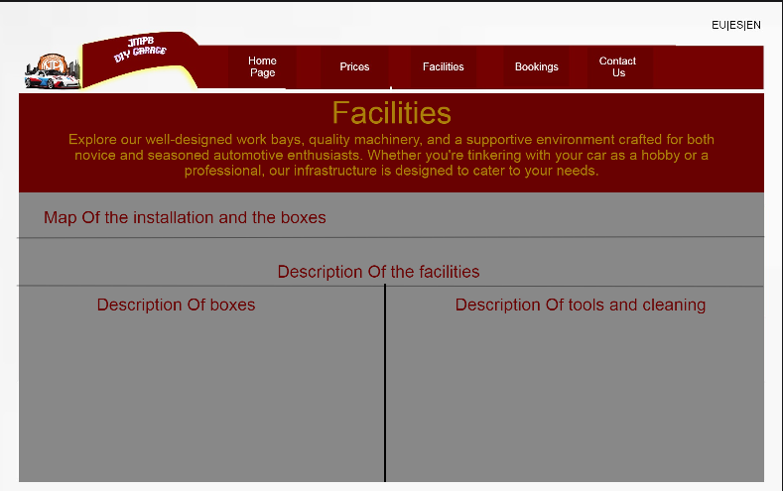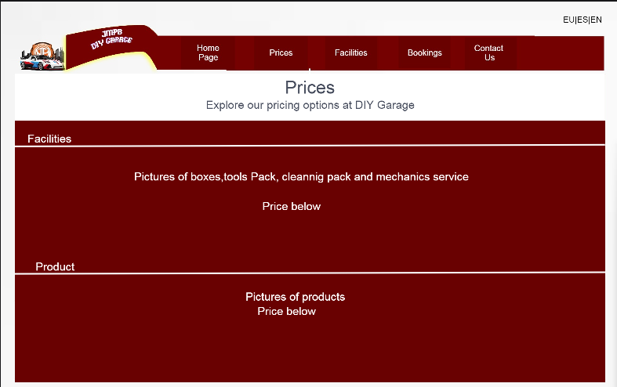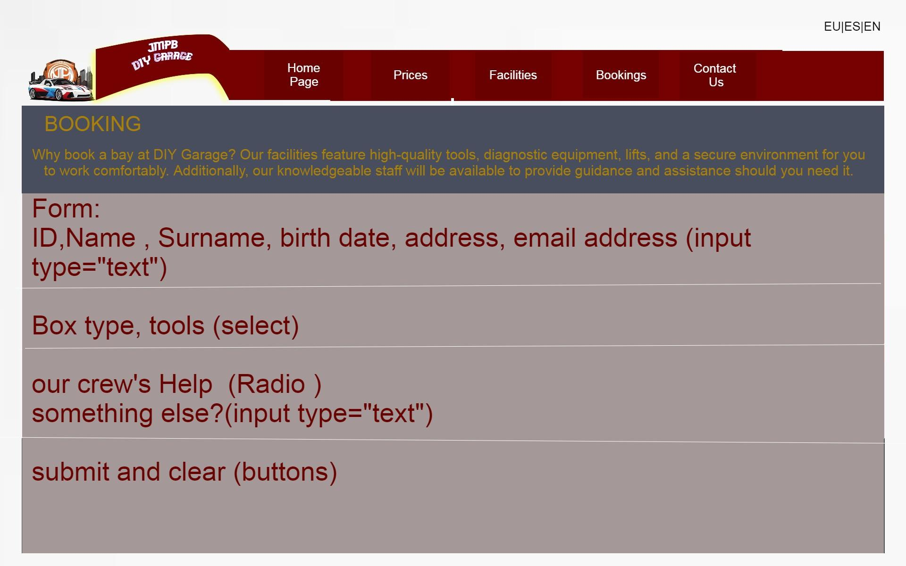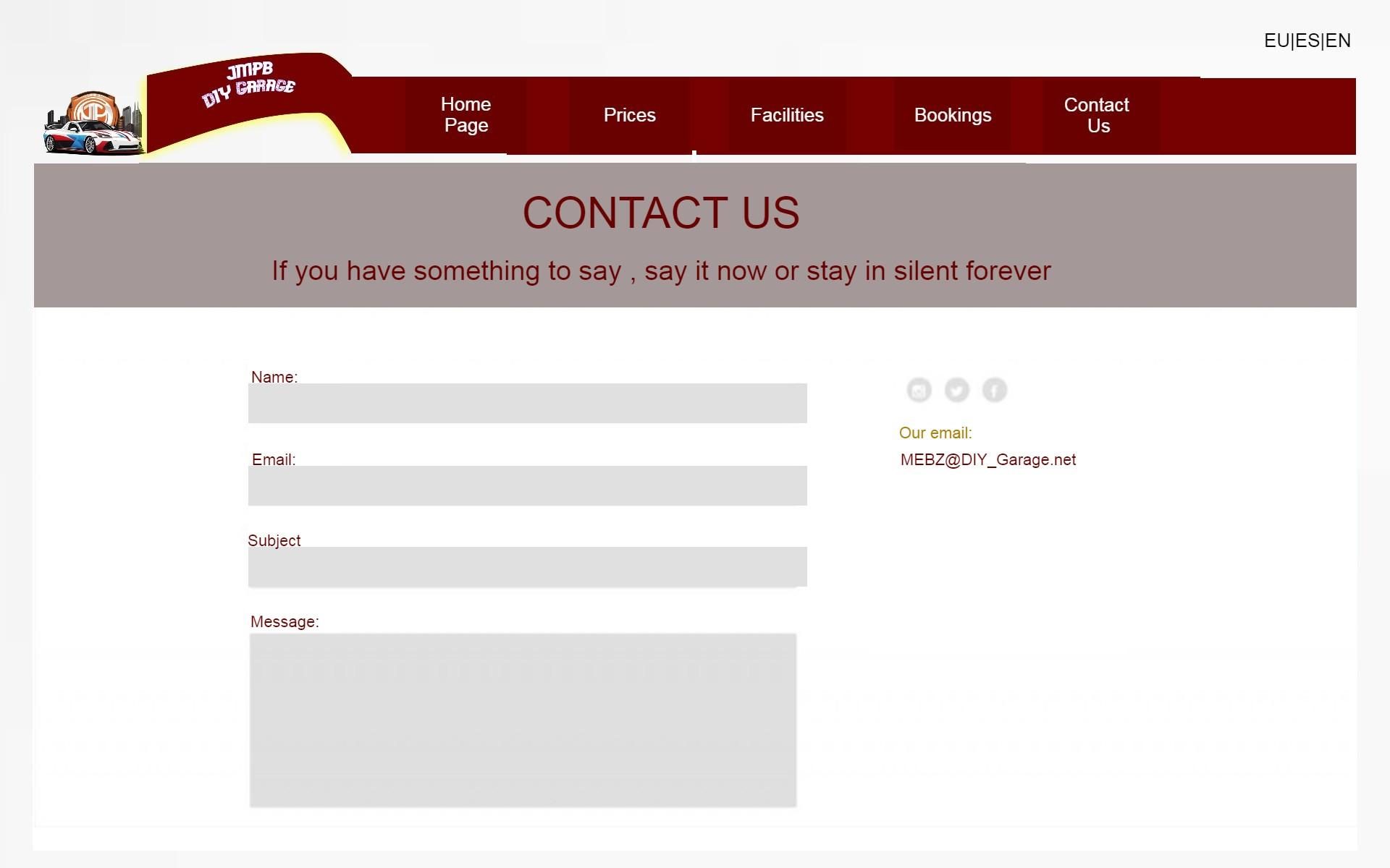

## ER DIAGRAM

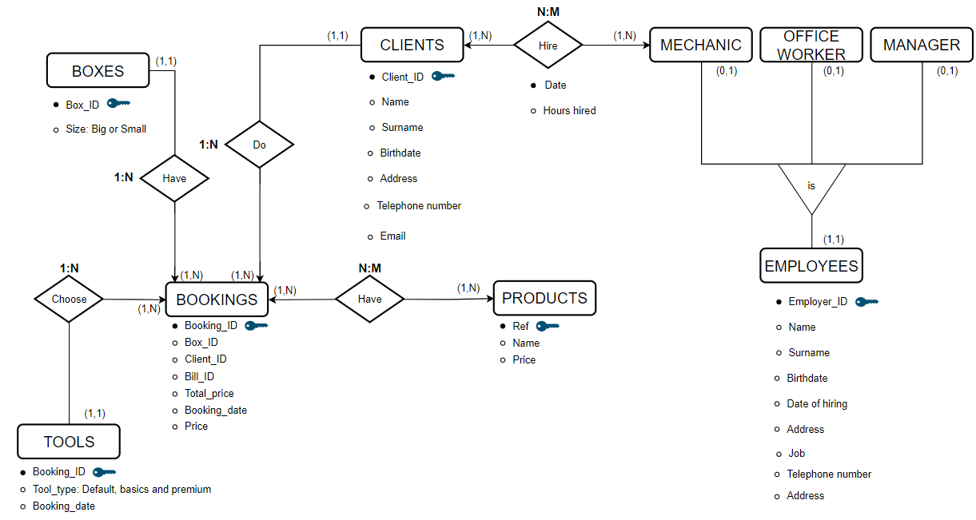

## C MENU

## 

## SYSTEMS

We will install windows 10 home in the pc’s of the office because it is easier for the user to use it and for the information transference and exchange they will use the lan connection.The user is expected to be only workers of the garage:

1. Kudeatzaile erabiltzeko
2. Idazkariak erabiltzeko
3. Administrazioan erabiltzeko
4. Bezeroei arreta
5. Zibersegurtasun arduraduna

If the user asks for it we can install a software for the information transference.

We also plan to make a partition for the operative system and other for the general use of the user. We want to keep the things simple for the user so it doesn’t get confused.We will also install the full pack of office software and the most common browsers too.

For the server we will use Windows server 2022 because it is the last version and the most used. The server will have a shared folder to store common software or other useful programs or documents that will be needed in the office. So this way if they buy a new pc they just have to download the programs and files from the shared folder. The users only can download and the employee who is in charge can download and upload new things to the folder.

The hardware will be the same as the one in the presentation. This is the list of components to make the computers: Asrock A520M-HVS, Aerocool CS-105 USB 3.0 Negra/Roja con Ventana, AMD Ryzen 5 3600 3.6GHz 32MB, Crucial CT16G4DFRA32A DDR4 3200Mhz PC4-25600 16GB CL22, NOX Hummer Alpha 600W 80 Plus Bronce, Samsung 870 QVO SSD 1TB SATA3, MSI AMD Radeon RX 6500 XT MECH 2X OC 4GB GDDR6, NGS Evo Zen Ratón Ergonómico Vertical Inalámbrico 1600DPI, MSI Vigor GK71 Sonic Teclado Mecánico Gaming RGB Switch Red, LG 34WN780P-B - Monitor UltraWide™ LG Ergo™, Cable HDMI 2.1 8K de Alta Velocidad 2m, Pack 5 Cables Ethernet Cat.6 RJ45 24AWG 1m.

This is the server: [Dell PowerEdge T40 Intel Xeon E-2224G/8 GB/1TB](https://www.pccomponentes.com/dell-poweredge-t40-intel-xeon-e-2224g-8-gb-1tb?campaigntype=pmax&campaignchannel=shoppingcampaignname=pmaxtopsem1&gclid=Cj0KCQjwqP2pBhDMARIsAJQ0Czq_NWnp3JpFJC1XXAzYbeQR_JKAWw18nlIKZ0BW-PhyIex7DPPVVdMaAvYTEALw_wcB)

